# TP5 Prog Web

## Question 0

## Question 1



## Question 2





## Question 3

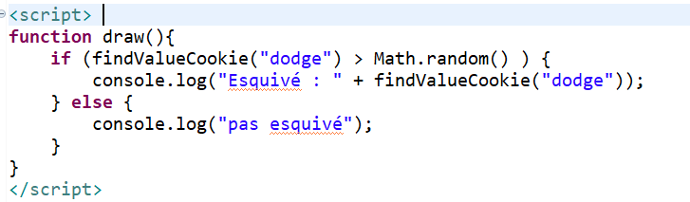

## Question 4/5

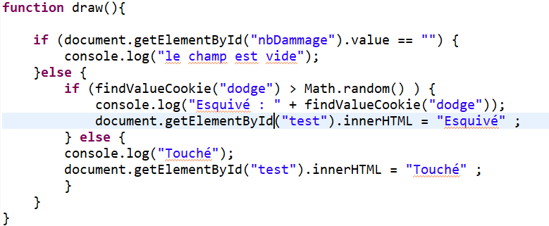

## Question 6 / 7

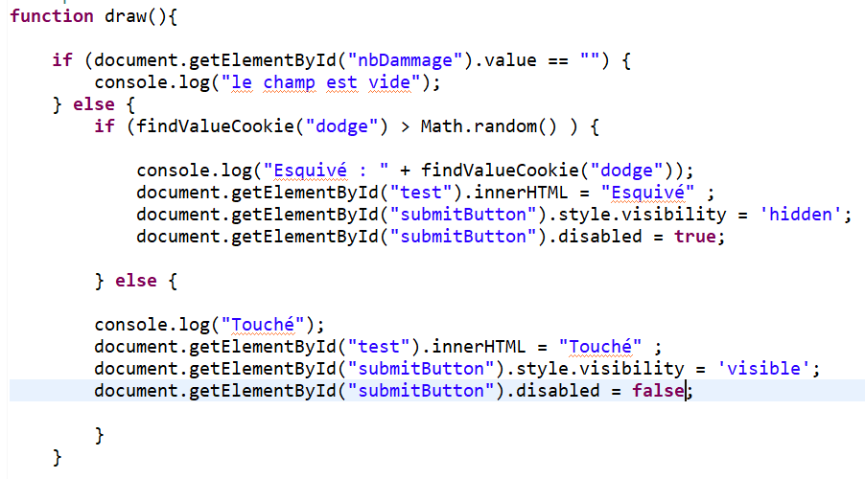

## Question 8



## Question 9





## Question 10/11/12/13

